200-53-364

Professor Rivas

MSCS-630L

Jan. 17th, 2018

Homework #0

Marcos Barbieri

**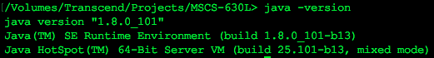Java Virtual Machine Runtime Environment:**

**Java Compiler:**

/Volumes/Transcend/Projects/MSCS-630L/crypt/hw/0/Barbieri_JavaCompiler.png

**Github User:**

**Github Repository:**

**Clone Link:** https://github.com/marcosb1/mscs630Barbieri.git